MSDS 7330

File Organization and Database Management Mini Project 2

Name: Cameron Stewart

This is a mini project for MSDS 7330, File Organization and Database Management. For this assignment, turn in a single pdf file containing all of your answers. The file should be named “yourLastNameMiniProject-Number.pdf". For example, the file name for my mini project 1 would be ‘RafiqiMiniProject-1.pdf’.

MySQL Database

Question 1: Create a database called “University”. Load the data and execute SQL queries.

I have attached scripts to create the University relations and also to add data. Once you have created the schema and loaded the data. Create SQL queries to answer the following questions:

1. Produce a list of all the students in the student relation, including their ID, name and department name, sorted into ascending order by their name.
   1. 
   2. 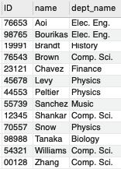
2. Produce a list of the names and salaries of professors in the Comp. Sci. and Elec. Eng. departments ordered by decreasing salary.
   1. 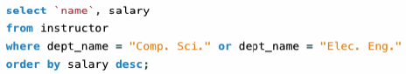
   2. 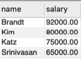
3. Find all courses whose identifier starts with the string ”CS-1”
   1. 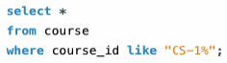
   2. 
4. Find the maximum and minimum enrollment across all sections, considering only sections that had some enrollment, don’t worry about those that had no students taking that section
   1. 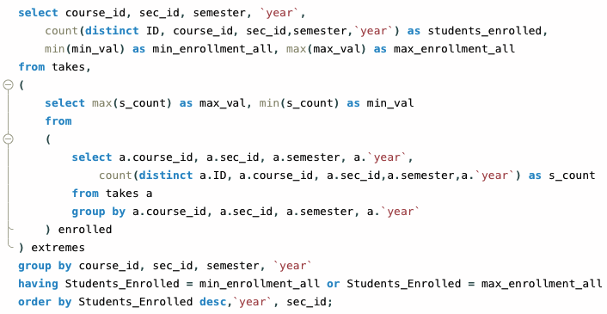
   2. 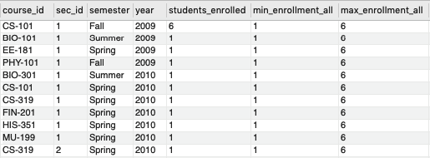
      1. Note: This table shows the courses with the min and max enrollment in one table. The top row is the course with the max enrollment and the bottom 10 rows tied for minimum enrollment.
      2. Note: min_enrollment_all and max_enrollment_all attributes represent the min and max for all sections and is repeated for each row as a reference for comparing the current students_enrolled.
5. Create a view faculty showing only the ID, name, and department of instructors.
   1. Create View
      1. 
      2. 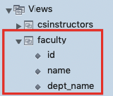
   2. Inside the View
      1. 
      2. 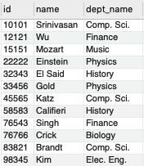
6. Create a view “CSinstructors”, showing all information about instructors from the Comp. Sci. department.
   1. Create View
      1. 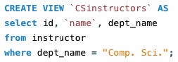
      2. 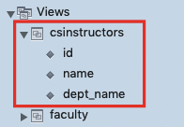
   2. Inside the View
      1. 
      2. 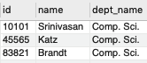

*Capture the sequence of queries and resulting output thereby demonstrating your database in operation. Turn in a pdf of screenshots of your database in operation.*